

SYSTEMS ANALYSIS AND DESIGN

**GROUP ASSIGNMENT**

**TECHNOLOGY PARK MALAYSIA**

**AAPP007-4-2-SYAD**

**UCDF1604ICT(SE)**

**MEMBER NAME :** NG WEN XUAN (TP041983)

**:** KUA CHUN KIT (TP042181)

**:** JEFFER LEE ZI FENG (TP041903)

**:** GAN HAO ZHAN (TP042328)

**NAME OF LECTURER :** MR. ABDULALEEM ZAID MOHAMMED AL- OTHMANI

**HAND OUT DATE :** 15th JUNE 2017

**HAND IN DATE :** 29TH SEPTEMBER 2017

**WEIGHTAGE :** 50%

Table of Contents

PART A - GROUP COMPONENT 3

1.0 Introduction 3

2.0 Problems and Proposed Solutions 4

3.0 Projects Planning 5

3.1 Software Development Life Cycle (SDLC) 5

3.2 Gantt Chart 7

7

4.0 Feasibility Study 8

4.1 Technical Feasibility 8

4.2 Economical Feasibility 9

4.3 Schedule Feasibility 10

4.4 Operational Feasibility 11

5.0 System Analysis 12

5.1 Fact Finding Techniques 12

5.2 Requirement Analysis 17

6.0 Design Diagram 18

6.1 Context Diagram 18

6.2 Level-0 DFD 19

6.3 ERD 22

7.0 Interface Design 23

7.1 Prototype of System 23

7.2 Concepts and Principles to Create Graphic User Interface (GUI) 29

PART B - INDIVIDUAL COMPONENT 30

NG WEN XUAN (TP041983) 30

8.0 Further Design 30

9.0 Testing and Maintenance 31

Kua Chun Kit (TP042181) 32

8.0 Further Design 32

9.0 Testing and Maintenance 33

Jeffer Lee Zi Feng (TP041903) 34

8.0 Further Design 34

9.0 Testing and Maintenance 35

Gan Hao Zhan (TP042328) 36

8.0 Further Design 36

9.0 Testing and Maintenance 37

References 38

Workload Matrix 39

# PART A - GROUP COMPONENT

## 1.0 Introduction

By continuing Peter’s family business, he became the owner of pizza shop named ‘Peter’s Pizzeria’ in the years of 2015. The main branch of his pizza shop was located at Bukit Jalil. With his perfect strategic of business managing skills, he succeeded to draw attention of various of customers. From May of 2016, his customer kept increasing at a surprising rate. On the first month of 2017, the earning of per month reached RM200, 000.

However, the serving system currently used in Peter’ shop was just simple as jotting down the order in a piece of paper. Some of the staffs are responsible to look after these papers of order, and eventually preparing the requested food according to the order. They even cannot provide a formal receipt for customers. There was only the shop name, location, contact number and the total price will be printed on the receipt. At the end of a day, Peter and some staffs had to stay up night late to update all items sold of a day into a spreadsheet of book while referring to the order papers. In fact, Peter‘s shop consists of only 6 numbers of waiters and staffs.

To manage Peter’s Pizzeria with more efficiency, an information system is required to develop. In the system software, which needs a function to monitor the stock level because it can mention that the ingredients will not out-of-stock easily. The sales record must store in the information system too because it allows the staffs to check the sales record efficiently, they can also reward their loyal customer based on their activity. Moreover, the information system needs to function as the ordering system which the staffs can help customers to order with a simple click. The type of transaction and delivery also should be included in this information system.

**There are several objectives to develop the information system:**

1. To be more efficient and save time to manage Peter’s Pizzeria by recording all orders and inventory details in the new system.
2. In order to develop the new system, 2 months of period are required.
3. Approximately RM 200,000 to accomplish the new system.
4. Delivery needs to include in Peter’s Pizzeria which able to increase the business marketing of Peter’s Pizzeria.
5. Have a better service for customers of Peter’s Pizzeria which able to order via internet. Customer will be more convenient and able to order the pizza from Peter’s Pizzeria at anytime and anywhere as long as there is internet service.

**Scope of the information system:**

1. Automatic updating is allowed in the new system which all data including order records, inventory details, staffs’ information and other will be stored automatically.
2. Online banking is available which allowing customer to order and pay via internet.
3. New system from website cannot support mobile application. Customer cannot make an online order by using mobile phone

## 2.0 Problems and Proposed Solutions

|  |  |
| --- | --- |
| **Problem 1** | Peter and staffs are spending too much of time to update the order record for back up and future referencing. |
| **Factor** | Peter and staffs should re-write order records into another spreadsheet book manually without helping of computing system. |
| **Implication** | Other important tasks such as inventory refreshment or delivery process will be delayed. Indirectly, they overall profits of business will be affected. |
| **Solution** | Auto updating system is required so that all the orders of each days will be recorded and saved automatically. Once staff or Peter places an order, all related information will be upload and stored safely in computer system as well as database. |

|  |  |
| --- | --- |
| **Problem 2** | Occasionally, occurrence of missing or spoiling of order paper lead to a lot of inconveniences. |
| **Factor** | Without helping of computing system, Peter’s staffs only jolt down all records in a piece of paper which is easily missing or spoilt by water. |
| **Implication** | Peter and staffs unable to prepare the wanted food or drink to that particular customer and this may draw of customer anger and damage shop image. |
| **Solution** | Missing from order records can be prevented by saving all data and information in the database. Other than that, saving data in different platform or devices such as server cloud or external hard disk is a great approach for back up. |

|  |  |
| --- | --- |
| **Problem 3** | There is too many customers order by telephone which needs to delivery. |
| **Factor** | Peter’s staff unable to handle the order when too many customers want to order. |
| **Implication** | Peter’s staffs unable to prepare the food or beverage for customer because they sometimes missing out the order or confuse with the order. |
| **Solution** | Customers can use the computer system by ordering online. Therefore, the staff can check the system then the staff will able to know the orders from customers without missing the order. |

|  |  |
| --- | --- |
| **Problem 4** | The security system for customers are unprotected. |
| **Factor** | Order paper that contain customers’ details will bring along with rider during delivery. This might happen loss of the paper and leak of customers’ details. |
| **Implication** | Customers will be in risk if their details leaked out and obtain by people with bad intention. |
| **Solution** | Peter could have a website for customers to register and login as a member. This will protect customers’ details as the details can only be seen in the website. |

|  |  |
| --- | --- |
| **Problem 5** | Couldn’t estimate sales and generate report. |
| **Factor** | The order and transaction records are missing or incomplete. |
| **Implication** | Without system support, Peter and his staffs couldn’t fully record all the sales, estimate and generate reports of which food are highly demanding and the amount of ingredients needed to restock, which will affect the inventory as they lack needed ingredients or stores too many unnecessarily ingredient which might expired. |
| **Solution** | Management Information System (MIS) should be implemented to manage the sales and inventory. |

## 3.0 Projects Planning

### 3.1 Software Development Life Cycle (SDLC)

#### 3.1.1 Planning

|  |  |
| --- | --- |
| **Problem Statement** | Figure out the obstacles and problems faced by Peter which is the current inventory and ordering system bring down the overall business performance. |
| **Initial Study** | Study the problem statement can discuss about the solution to tackle it. In order to cope with the problem of the current system. A computing system is introduced to boost up Peter‘s business. The solution is written in Initial Study Report. |
| **Feasibility Study** | Once the initial study report is approved, feasibility study should be carried out to ensure the project has reasonable probability to be successful.  Type of Feasibility Study:   1. **Technical Feasibility:** Develop team discusses about is the organization has ample technical resources such as software, hardware, and people. 2. **Schedule Feasibility:** Develop team should ensure the organization has adequate time to accomplish the project with given deadline. Reviewing the Gantt chart that planned earlier and compare to the actual time given to determine the feasibility of building the new system with the given time. 3. **Economic Feasibility:** Cost table is created and all the cost including tangible, intangible, direct and indirect cost is listed down in the table. Eventually, calculate out the total cost of the system from the table and determine whether the budget is affordable to build the new system. 4. **Operational Feasibility:** Discuss how the new system will benefit the end-user by studying the PIECES framework which including performance, information, economy, control, efficiency and service. |

#### 3.1.2 Analysis

|  |  |
| --- | --- |
| **Requirement Analysis** | Gathering data and requirement by using Fact-finding technique such as interview, document review, observation and questionnaire survey. The definition, advantages, disadvantages as well as step of each technique are defined. |
| **Study Complied Requirement** | Based on the finding from those fact-finding techniques, narrow down the requirement and need which are significant. |
| **System Requirement Specification** | Identify the system requirement, user requirement, functional requirement and non-functional requirement. |

#### 3.1.3 Design

|  |  |
| --- | --- |
| **Design New System** | Create the storyboard for new system as a draft. |
| **Create Prototype** | Start building the prototype of the system without any coding and function based on the system requirement specification. |
| **Design Specification** | Identify the need of the system that should be achieved by developer such as the database structure, ERD diagram, |

#### 3.1.4 Implementation

|  |  |
| --- | --- |
| **Building System** | Start building the actual component of system such as security system, database, end-user license agreement, animation and graphical element. |
| **Testing** | Checking process such as unit testing, integration test and system testing is carried out to ensure the system is useable and capable to handle any predicted situation with error.  Type of Testing:   1. **Unit Testing:** Test a unit of system component such as log in page. 2. **Integration Test:** Test 2 or more linked pages such as log in page to register page. 3. **System Testing:** Test the system in different server and browser. |
| **Deploying System** | Deploy and release the new completed system and ready for the use of end-user. |

#### 3.1.5 Maintenance

|  |  |
| --- | --- |
| **Maintenance Task** | It very important during the system’s operational life and includes spending to support maintenance activities. It can ensure correct system performance, adapt the system to changing requirements and make the system operate more efficiently.  Types of Maintenance Tasks:   1. **Corrective Maintenance:** Fixing and debugging the error for particular component to solve the problem faced by user. 2. **Adaptive Maintenance:** Making the system adaptive by changing the system to suit will the changing environment. 3. **Perfective Maintenance:** Maximizing and upgrading all the resources of system to make the system as perfect as possible. 4. **Preventive Maintenance:** Upgrading the system to prevent future problem. |

### 3.2 Gantt Chart

### 

## 4.0 Feasibility Study

### 4.1 Technical Feasibility

|  |  |
| --- | --- |
| **Definition** | The process of validating the technology assumptions, architecture and design of a product or project (Simplicable.com, 2017). By studying this feasibility, developer able to determine technology resource of organization including software, hardware, people, facilities and so on. |
| **Question 1** | Do we currently possess necessary technology? |
| **Answer** | Yes. We have enough number programmer and other essential hardware and software such as Visual Studio and multiple high-performance computers which using i7 processor and contains GTX-1080 as graphic card. |
| **Question 2** | Do we have the ample of concept and facilities to develop the new system? |
| **Answer** | Yes. We have a clear image and concept about the new system based on the information domain from Peter as well as functional domain and behaviour domain. Beside we also possess needed facilities and tools to deal with the new system. |
| **Question 3** | Do we are technical expertized? |
| **Answer** | Yes. Within are team, there are several experienced and skilful programmers and designer. |
| **Question 4** | Is the new system practical? |
| **Answer** | Yes. The new system is helpful and efficient as it possesses a couple of automatic functions which make Peter’s business easier. For instance, new system provides database system that allowing peter to store data and reduce risk to data losing. |
|  | |
| **Conclusion** | Technical feasibility success. |

### 4.2 Economical Feasibility

|  |  |
| --- | --- |
| **Definition** | The process of identifying the financial benefits and costs associated with a development project. It is performed when conducting a preliminary investigation, evaluating a project and making recommendation to management. |
| **Costing Table** | |  |  |  | | --- | --- | --- | |  | **Direct Cost** | **Indirect Cost** | | **Tangible Cost** | * Computer   🡪 RM20, 000   * Dreamweaver   🡪 RM2, 000   * Server Rental   🡪 RM500 | * Broadband cost   🡪 RM500   * Printer   🡪 RM500   * Extension card   🡪 RM10, 000 | | **Intangible Cost** | * Programmers’ salary   🡪 RM80, 000   * Customer dissatisfaction   🡪 RM5, 000   * Resource’s Fees   🡪 RM1, 000 | * Staff training   🡪 RM2, 000   * Transport Fees   🡪 RM500   * Insurance expenses   🡪 RM4, 000 | | **Total** | RM108, 500 | RM17, 500 | |
| **Question 1** | What is the budget given for the new system? |
| **Answer** | The budget given for the new system is RM200,000. |
| **Question 2** | How much is the total cost for entire development? |
| **Answer** | The total cost for entire development is RM122,000. |
| **Question 3** | What is the profit after building the new system? |
| **Answer** | The profit after building the new system is RM74,000. |
|  | |
| **Conclusion** | Economic feasibility success. |

### 4.3 Schedule Feasibility

|  |  |
| --- | --- |
| **Definition** | The process of assessing the degree to which the potential time frame and completion dates for all major activities within a project meet organizational deadlines and constraints for affecting change (Iamglyka.Wordpress.com, 2013). Basically, this feasibility study allow developer to know whether they have adequate time to accomplish their task with the given deadline. |
| **Grant Chart Report** | |
| **Question 1** | How much time is given to develop the new system? |
| **Answer** | The time given to develop the new system is 100 days. |
| **Question 2** | What are the actual time that we need to develop the new system? |
| **Answer** | The actual time we need to develop the new system is 81 days. |
| **Question 3** | What should we do when the actual development exceeds the given deadline? |
| **Answer** | Discuss with the buyer to extend the days to develop the system. |
|  | |
| **Conclusion** | Schedule feasibility success. |

### 4.4 Operational Feasibility

|  |  |
| --- | --- |
| **Definition** | The process of assessing the degree to which a proposed system solves business problems or takes advantage of business opportunities. This feasibility study is to let the developer to understand the functions and aim for the project, whether it is worthy to carry on with the measure of problem solving and effectiveness of the system. |
| **Question 1** | Does the new system perform faster than the old system? |
| **Answer** | Yes. The processing time will be short, response is snappier than before, with all the automatic function and digitalize system the productivity will increase. |
| **Question 2** | Does the new system provide better data and information? |
| **Answer** | Yes. The data and information provided are accurate and detailed, workers will access to the completed data in time. |
| **Question 3** | Is the new system cost effective? |
| **Answer** | Yes. It will generate report automatically which will save the cost to hire a worker to work with the reports. It will also reduce the cost of stationary and papers which is used to take orders. |
| **Question 4** | The new system is more secure? |
| **Answer** | Yes. Only authorized staff can access to important data and it support more secure payment method which is online banking. |
| **Question 5** | Does the new system require more resources? |
| **Answer** | Yes. The system requires basic hardware and software which able to support it, such as computer, RAM, processor and operating system, it also requires at least one worker to operate the system. |
| **Question 6** | Is the new system allowed to do more thing or provide more function? |
| **Answer** | Yes. The services in the system includes customer reward system, online order and delivery, besides, it is flexible and expandable in future maintenance which more function could be added in. |
|  | |
| **Conclusion** | Operational feasibility success. |

## 5.0 System Analysis

### 5.1 Fact Finding Techniques

#### 5.1.1 Interview

|  |  |
| --- | --- |
| **Definition** | The definition of an interview is a formal [meeting](https://www.collinsdictionary.com/dictionary/english/meeting) at which someone is [asked](https://www.collinsdictionary.com/dictionary/english/ask) questions in order to [find](https://www.collinsdictionary.com/dictionary/english/find) out if they are [appropriate](https://www.collinsdictionary.com/dictionary/english/suitable) for a job. In sort, interview needs the skills which to plan, conduct and document interviews. Meanwhile, interview is an information-gathering is a directed interlocution with a specific purpose that uses a question and answer format. The most significant of interview is seek the opinion of the person who you are interviewing as opinion are more important than truths. |
| **Advantages** | 1. Interview can reduce the misunderstanding of the meaning of the interviewee. That is because if interviewers have any misunderstand or not clear can directly ask the interviewee. 2. Interview can help interviewer in depth analysis to the interviewee. The interviewer can get the detail information and secret of the interviewee with face-to-face communication. Therefore, interviewer may modify as need to gather important information. 3. Interview allows the applicant to ask questions that may reveal additional information useful for making a selection decision. The applicants can to the interviewee directly if they have any misunderstanding or not clear about the job. |
| **Disadvantages** | 1. Interview is a type of fact-finding technique which are consuming time. That is because preparation for the interview, taking interview and interpretation of the responses need to much time. 2. Interview will limit the sample size because interview is limit to a small area of people which cannot universal as the online questionnaire that anyone also can participant. 3. Interview require a highly skilled interviewer. If an interviewer who lack of experience to interview, he will miss out some of the expert person. |
| **Target People to Interview** | * **Staff:** To understand if there has any improvement of the current system use of Peter’s Pizzeria and get the staff’s insight to improve the system. * **Customer:** To get the feedback of customer about the purchase or delivery process. |
| **General Interview Steps** | **Step 1:** Determine the people to interview.  **Step 2:** Establish objectives for the interview.  **Step 3:** Develop interview questions.  **Step 4:** Prepare for the interview.  **Step 5:** Conduct the interview.  **Step 6:** Document the interview.  **Step 7:** Evaluate the interview. |
| **Sample Interview Questions** | 1. **May I have your opinion about the delivery process of** Peter’s Pizzeria**?** 2. May I have your opinion about the online transaction system of Peter’s Pizzeria? 3. Based on your opinion, what do you think about the Peter’s Pizzeria did not have a formal receipt? Will you support us continuously? 4. Do you satisfy to the current system of Peter’s Pizzeria? Why? 5. Based on your opinion, what improvement should be carry out to deal with the problem face such as loss of the ordering record and the inventory record? |

#### 5.1.2 Questionnaire

|  |  |
| --- | --- |
| **Definition** | Questionnaire is a list of research or survey questions that asked to respondents and designed to collect specific information. It has four basic purposes, they are collect appropriate data from respondents, used to make data comparable and amenable to analysis, minimum bias in formulation and asking question face to face as some respondents will refuse to answer the questions, and to make questions attractive and varied. |
| **Advantages** | 1. Practical training could help researcher to gain more experience in the future. 2. Huge quantity of information can be collected from various number of people in a short period of time and in a relatively cost-effective way. 3. It can be carried out with minimum affect to its validity and reliability. 4. The result of questionnaire can be easily concluded by either the researcher or the software used. 5. Questionnaire can be more scientifically and objectively than other forms of research. 6. Data can be used to compare with other research. 7. It can be used to create new theories or text existing hypotheses. |
| **Disadvantages** | 1. Is argued to be inadequate to understand some forms of information - i.e. changes of emotions, behaviour, feelings etc. 2. Questionnaire only asking a limit amount of questions without any description and this case phenomenologists state that this research is simply an artificial creation by the researcher. 3. Lacks validity. 4. Researcher doesn’t know the truthfulness of respondents. 5. Researcher is unknown about how respondents answer the questions will full effort. 6. The respondent may just simply answer the questions. 7. Diverse people will have diverse answer for the questions as respondents are replying based on their own interpretation What is good to someone may be poor to someone else, therefore there is a level of subjectivity that is not acknowledged. 8. There is a level of researcher imposition, when developing the questionnaire, the researcher will easily miss out something importance as they make the questionnaire on their own decisions and assumptions as to what is and is not important. |
| **How to Distribute** | 1. Distributed by emailing to diverse people or friends that we know. 2. Distributed in google form via WhatsApp. 3. Distributed through hardcopy to staff. 4. Distributed via online to customers. |
| **General Questionnaire Steps** | **Step 1:** Write a study protocol.  **Step 2:** Draw a plan of analysis.  **Step 3:** Draw a list of the information needed.  **Step 4:** Design different parts of the questionnaire.  **Step 5:** Write the questions.  **Step 6:** Decide on the order of the questions asked.  **Step 7:** Complete the questionnaire.  **Step 8:** Verify the content and style of the questions.  **Step 9:** Refine your questionnaire. |
| **Sample Questionnaire Questions** | 1. Likert scale e.g. How do you rate the food in canteen? |

#### 5.1.3 Observation

|  |  |
| --- | --- |
| **Definition** | The definition of an observation is the act of noticing something or a judgment or inference from something seen or experienced.  In short, observation is a process to study targeted unit, groups or process by seeing, watching, noticing or capturing. Meanwhile, asking is allowed during observing to gain further information and details. |
| **Advantages** | 1. Observer can get direct feedback form subject by asking and questioning. 2. Observer able to understand and experience the situation as well as environment of process. 3. Observer can capture all the steps of process by jolting down note and recording to create manual. |
| **Disadvantages** | 1. Observation may consume a lot time to study entire process. 2. The degree of interpretation is depended on the observer. Therefore, observer should acquire a great interpreting skills and observation skills. 3. Hawthorne Effect Productivity has to be considered as the subject may improve their productivity whenever they are being observed. 4. Observer hard to create an accurate analysis or result after observing since 5. Observation contain higher risk of bias as the observer may include their own insight, opinion as well as feeling and eventually effect the analysis process. |
| **General Observation Steps** | **Step 1:** Select a target group, process, or people to be observed.  **Step 2:** Paying attention. Attention. Observer has to pay full attention while observing the process in order to obtain fully understanding and information about the process.  **Step 3:** Retention. Observer should able to remember what they observed. Taking note and recording are the best method to capture the step of process.  **Step 4:** Reproduction. Based on what had been observed, observer and researcher should be to perform it again.  **Step 5:** Motivation. |
| **Example Process That Could Be Observed** | 1. Process of placing or taking order of customer by staffs. 2. Process of inventory managing such as checking up the available inventory and refilling stock. 3. Process of product booking. |

#### 5.1.4 Document Review

|  |  |
| --- | --- |
| **Definition** | Document review is a data collecting method by reviewing existing documents. The documents may be internal to a program or organization or may be external. It could be either hard copy or electronic ( Centers for Disease Control and Prevention (CDC), 2009). |
| **Advantages** | 1. Most of the document already existed, therefore the cost for data collection is lower than other method. 2. Understand the system and the process of system and documents. 3. Provides different aspect of the system which can’t be observe directly. |
| **Disadvantages** | 1. Document and data might be out of date or inaccurate. 2. Time consuming for gather, evaluation and analyse different data and documents. 3. Might be biased for selective of survival document and information. |
| **Websites or documents to review** | 1. Customers placing order over phone or online. 2. Feedbacks and performance rating from customers. 3. Proposal of the new system. |

### 5.2 Requirement Analysis

#### 5.2.1 User and System Requirement

|  |  |
| --- | --- |
| **User Requirement** | **System Requirement** |
| Admin should be able to manage the stock of product and inventory such as update item’s quantity. | The database system is fully encrypted and password protected so that on one else can read and access the database directly. |
| Manager should be able to view all sale report for both store and online. | System use supercomputer to maintain its server and use Mac OS X Server as its operating system which can handle the entire server effective and efficiently. |
| Member and admin are allowed to make and place order for pizza purchasing. | System includes Transaction Processing System (TPS) which able to handle large amount of input and output data efficiently and accurately. |
| Member/customers can get their ordered food via delivery service. | System includes Management Information System (MIS) which provide auto-reporting service base on the data from database. |
| Customer able to proceed their payment via credit card. | System contains Decision Support System (DSS) which will highlight the most sale of product for manager and narrow down the options. |

#### 5.2.2 Functional and Non-functional Requirement

|  |  |
| --- | --- |
| **Functional Requirement** | **Non-functional Requirement** |
| System allow admin to monitor stock such as updating and adding new products. | System able to support multiple users simultaneously without bringing down the server. |
| System able to generate report for the manager automatically based on the sale and order. | System provide different view for different user where the view of member is limited while admin view has higher accessibility. |
| System allow customer to purchase pizza via internet after registered as member. | System contains pop-up alert message which act as a confirmation message for user action such as log out or delete data. |
| System provide delivery service for customer. | System provide password recovery function which cope with the problem of forgot password |
| System must provide more than one platform of online banking service. | System user interface provides night mode which can reduce the lightness during the night so that the user can use it at night time. |

## 6.0 Design Diagram

### 6.1 Context Diagram

### 6.2 Level-0 DFD

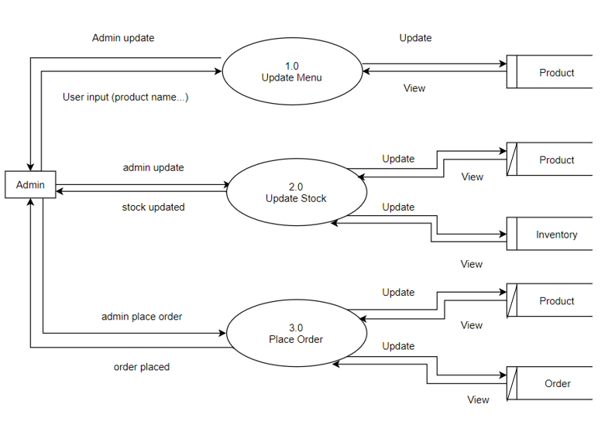**Admin**

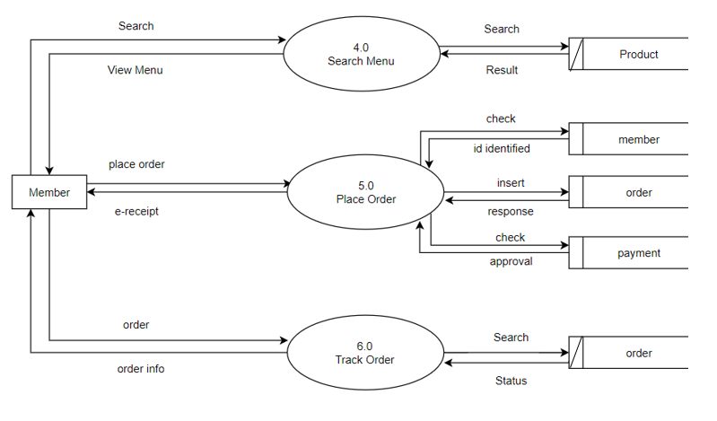**Member**

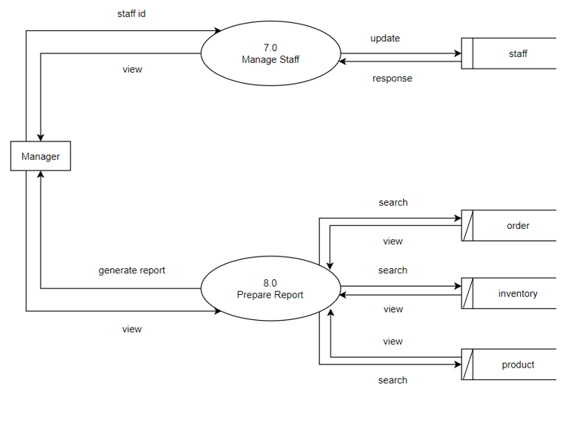**Manager**

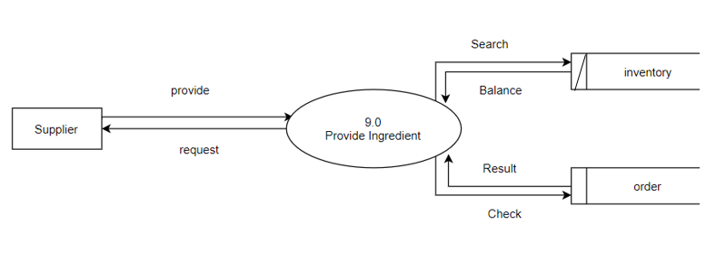**Supplier**

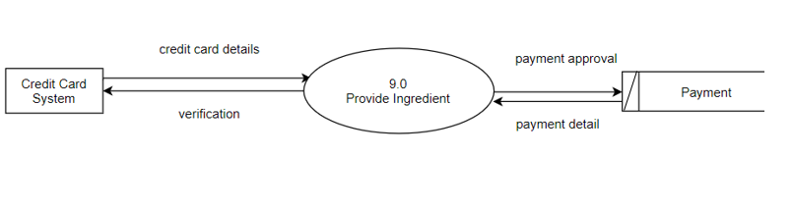**Credit Card System**

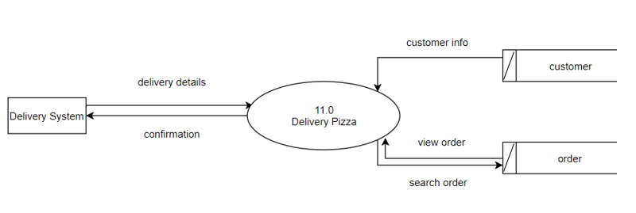**Delivery System**

### 6.3 ERD

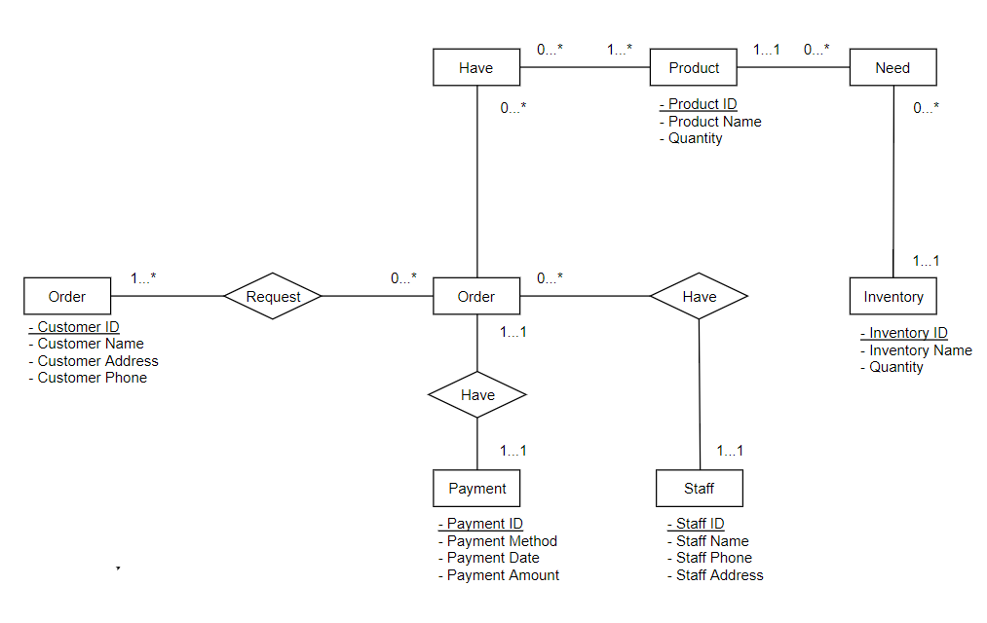

## 7.0 Interface Design

### 7.1 Prototype of System

#### 7.1.1 Customer

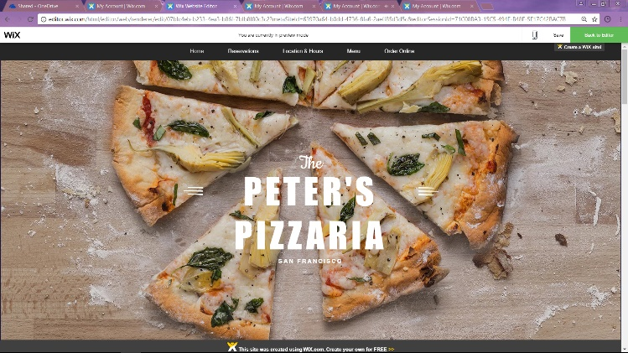**Main Page**

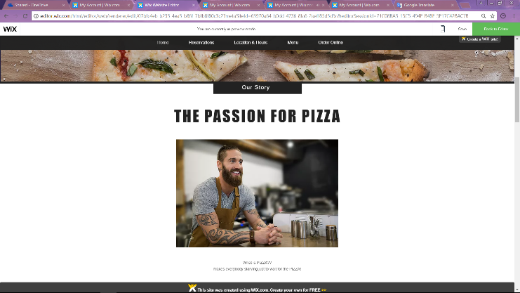

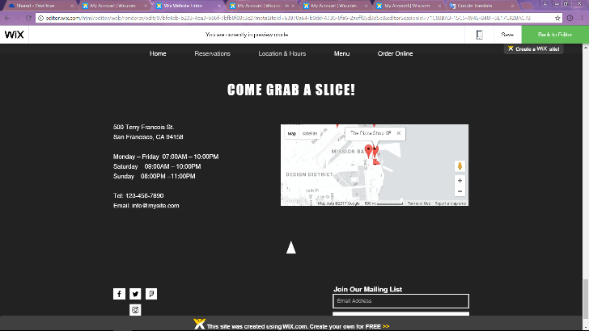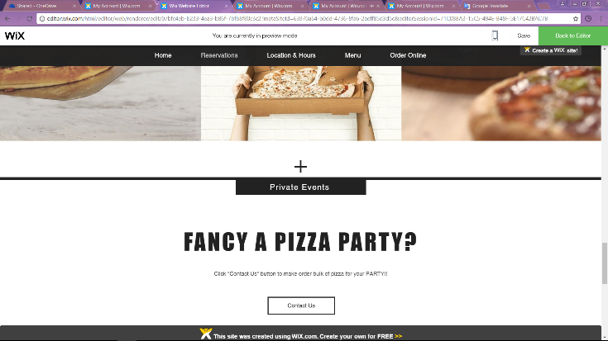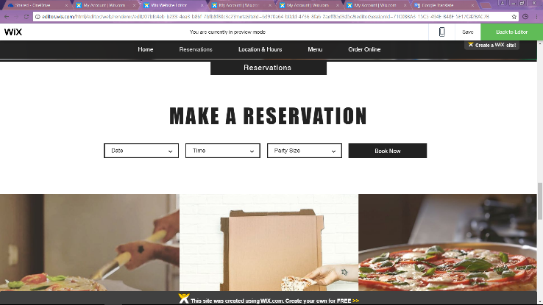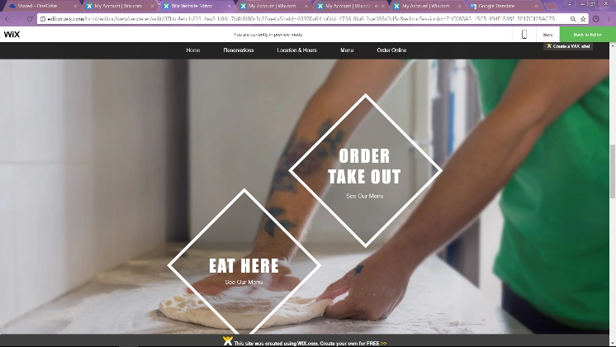

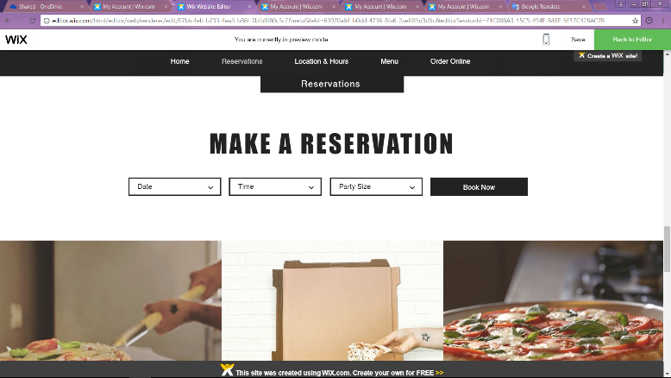**Reservation Page**

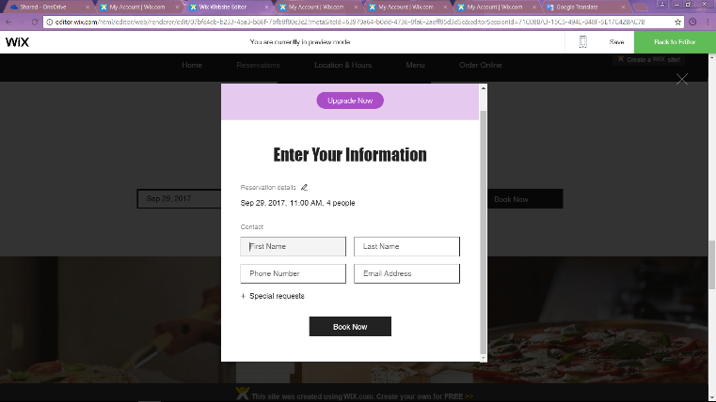

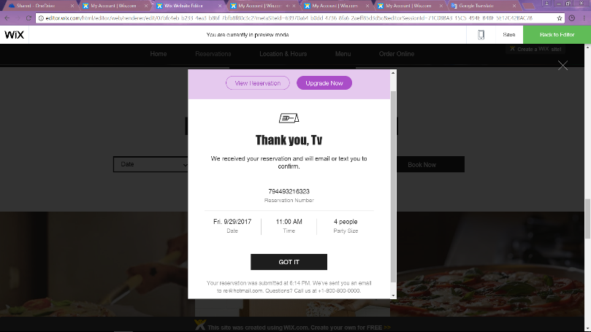

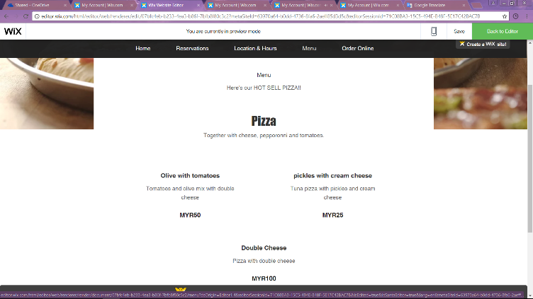**Menu Page**

**Order Online Page**

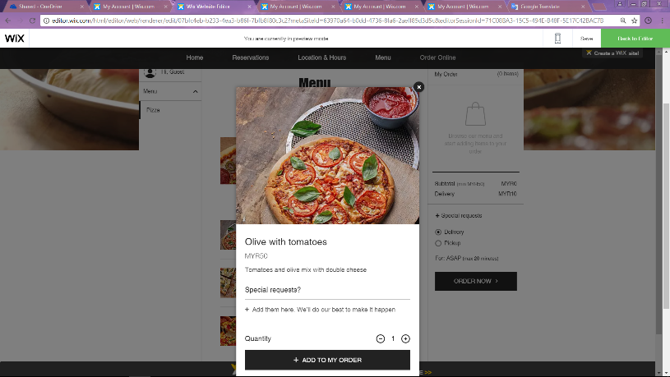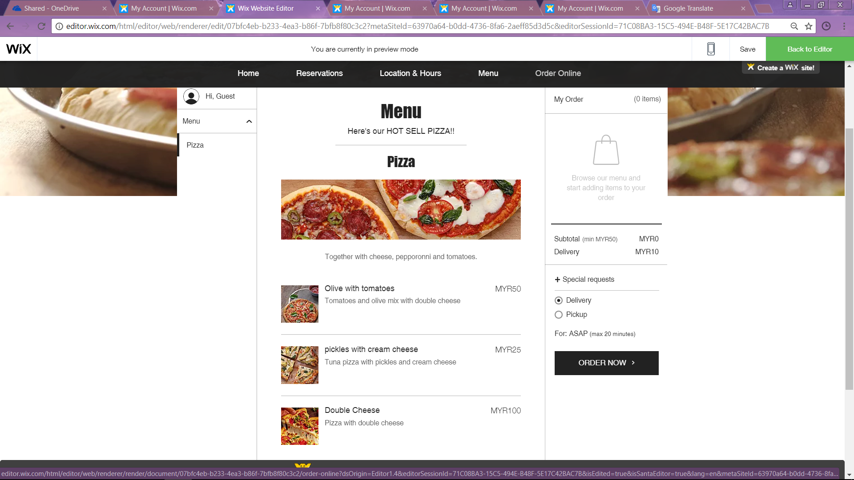

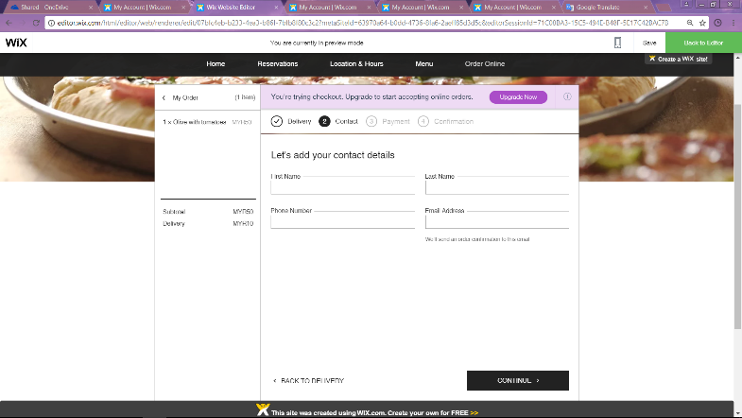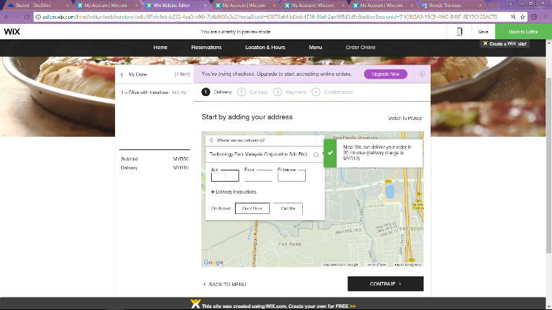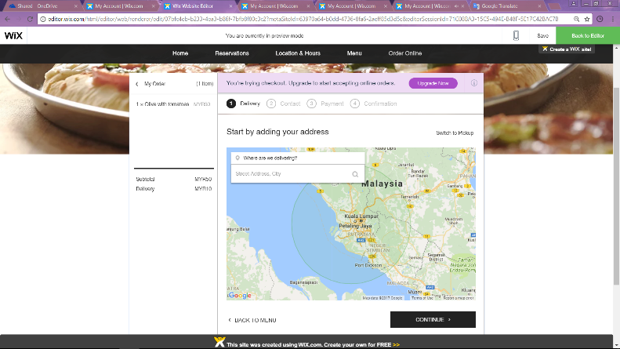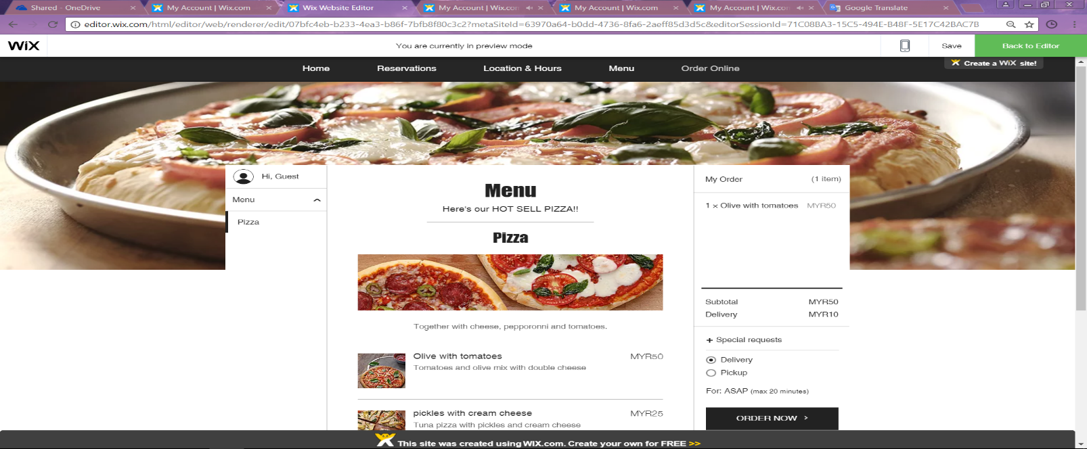

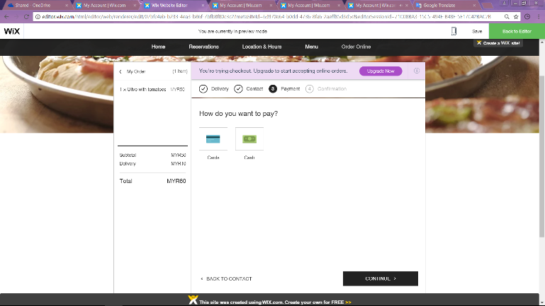

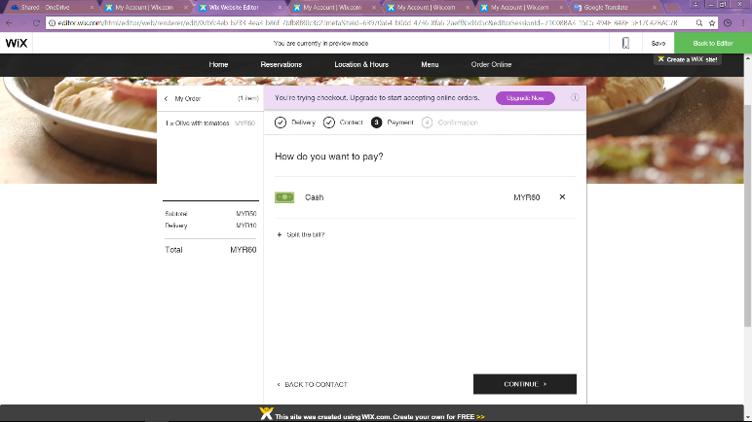

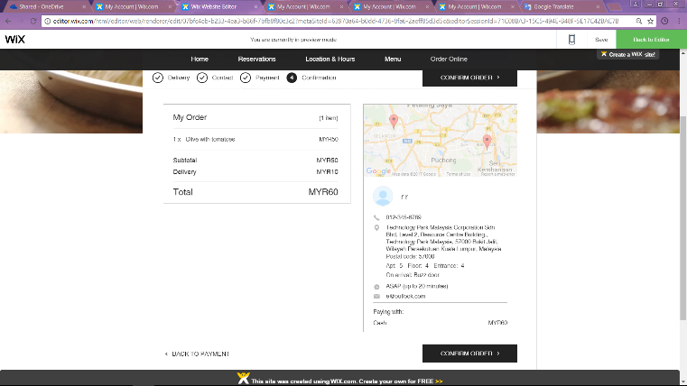

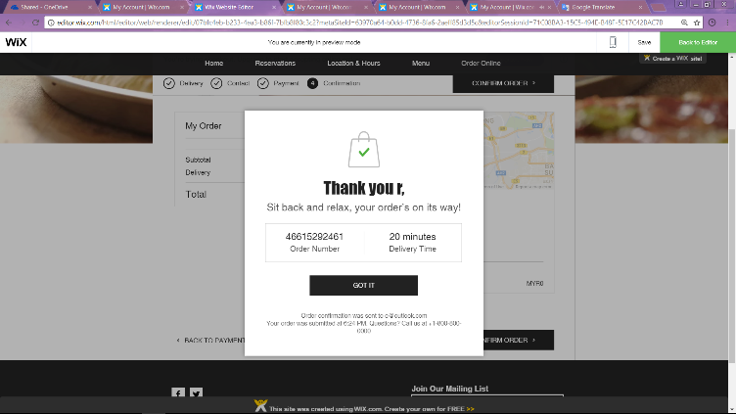

#### 7.1.2 Admin

**Edit Information of Website Page**

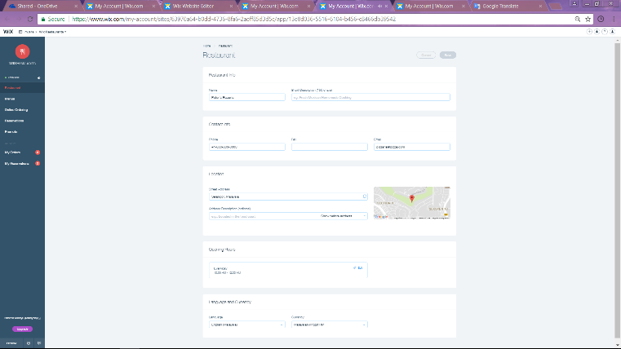

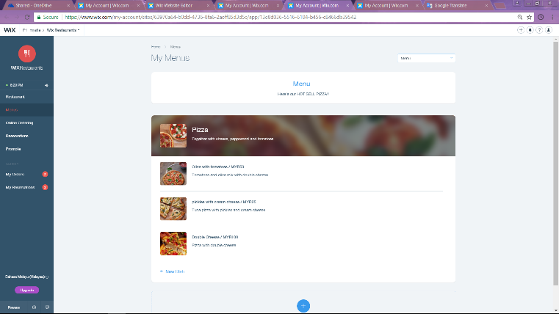

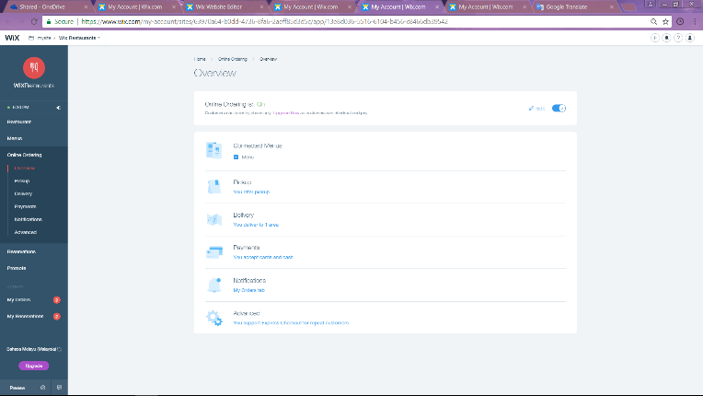

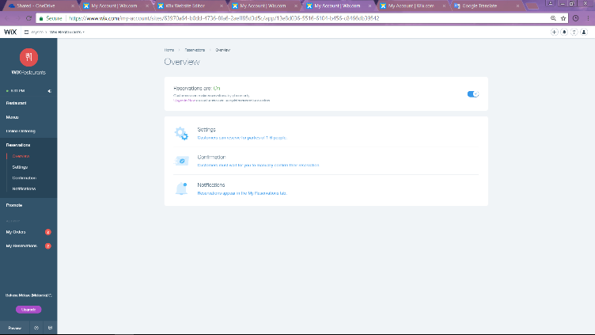

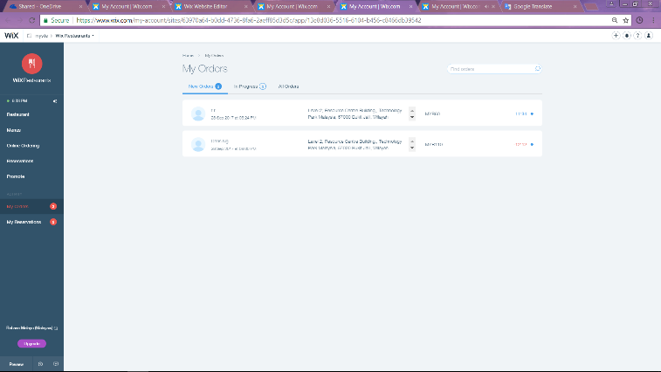**Track Order Page**

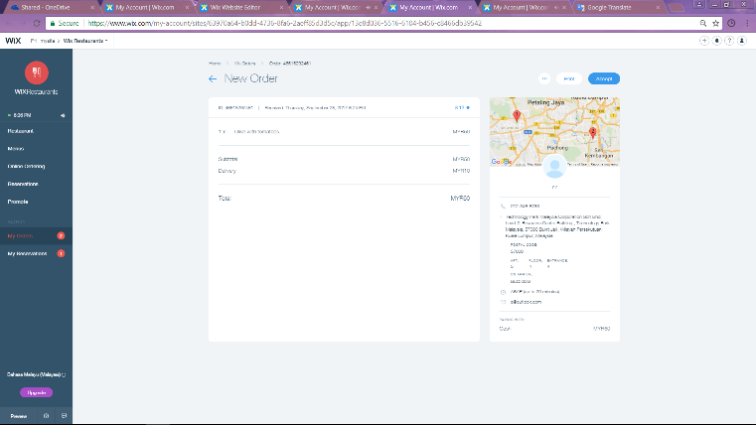

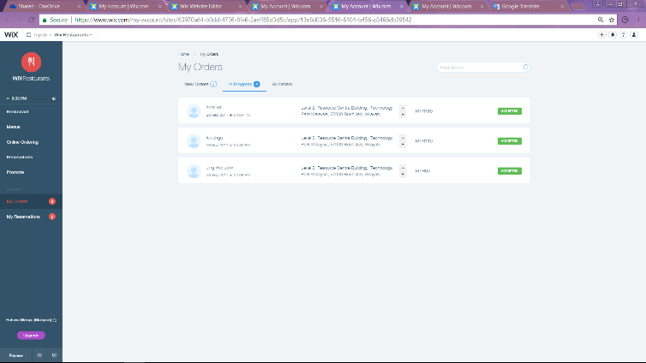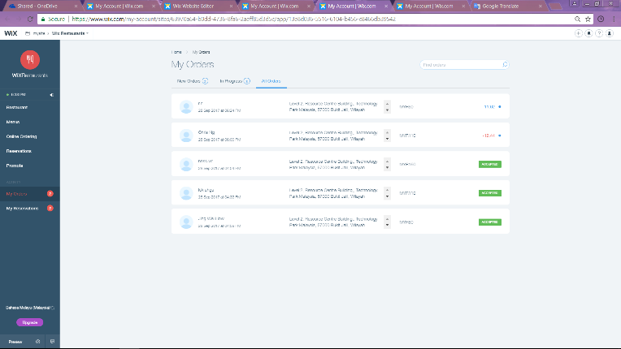

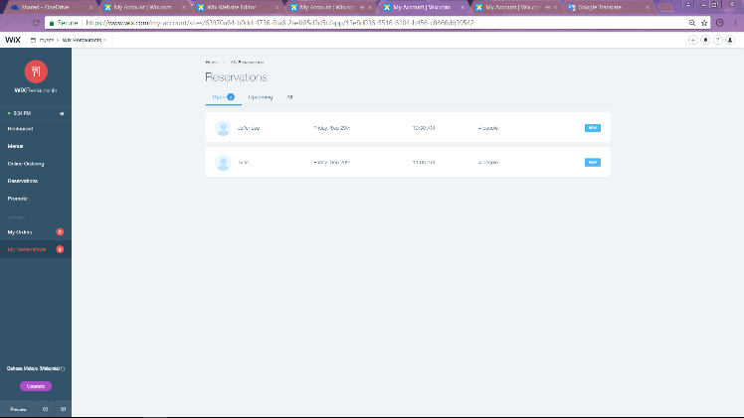**Track Reservation Page**

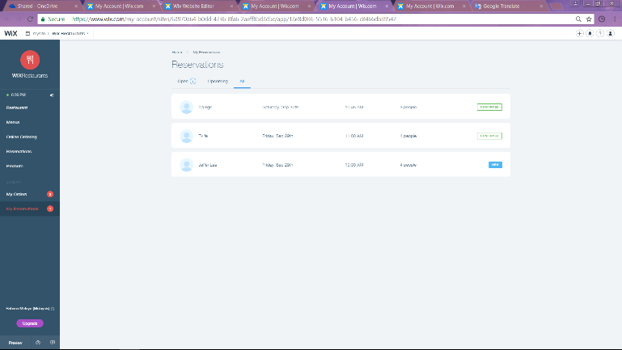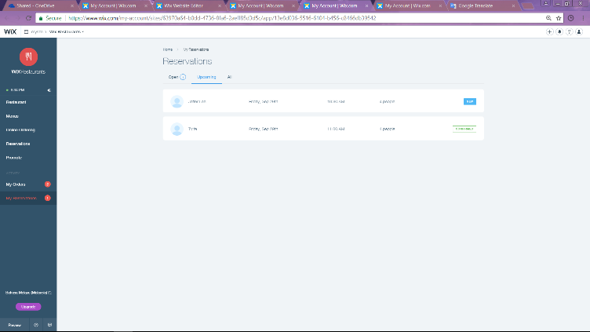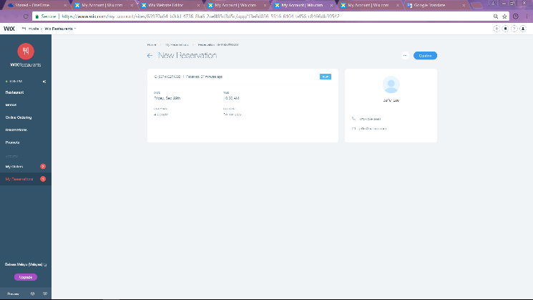

### 7.2 Concepts and Principles to Create Graphic User Interface (GUI)

In order to develop a helpful and great website, there are a couple of aspect that we have to focus on. First and foremost, the website should have good navigation. What is mean by good navigation? The website should be able to navigate to a desired destination. By providing clear and direct navigation, user can easily visit the target page and information accurately without getting lose while using the website. For example, providing a clear and simple menu bar and contain a couple of sub-menu or drop-down list inside it is a good example of useful navigation menu as user able to navigate to any targeted page as simple as clicking the option from menu bar.

Furthermore, to make the website to be attractive, appropriate color should be used. Color is paramount important in a website as it able to get user’s attention. No matter the color of font, background or all the controls, a colorful design help to improve the overall appearance of website l. According to the research, colorful note able to imprint reader’s mind longer than a monochrome note. Reader may raise their intention of reading to read the colored note instead of a black-and-white note and ward off the stressful feeling while reading. Nevertheless, the use of color should be appropriate and too light which are difficult to read by user.

In addition, the following attribute that a good website should have is the website should have contact information. Communication plays vital role within people. Information can only be transferred by communication. Therefore, website should contain contact details such as company phone number, address, email, and other social apps link to act as communication platform for user to contact the company and ask for further information.

Moreover, the size of the graphical element should be smaller. This is because the larger the size of graphical element, the longer the time to be needed to load the entire media file completely. If the internet speed of user is slower, the total time taken to load the media will be extend more. As such, the size of picture should be converted as small as possible and provided another button for user to view the original full-size file. This is also same going with the video in website where the resolution of video clip is able to adjust.

Last but not least, ensure that the text of the Graphic User Interface (GUI) easy to read. Text is significant. It’s there to provide information to the users. Hence, do not make the readers squint to read it. In this case, ensure the colors of GUI work together. For example, on a white background, it should be in cream colored text. Font size of the GUI also one of the important points. Don’t use uber-tiny font size. While it might look cute, it’s just not practical. Ensure the users would not need a magnifying glass to figure out your message. Thus, stand by your fonts. Create a theme which no more than three font styles and the font style should be cautious. Ensure the font style you select are reader-friendly and do not leave the users wondering if they are reading Sanskrit.

# PART B - INDIVIDUAL COMPONENT

## NG WEN XUAN (TP041983)

### 8.0 Further Design

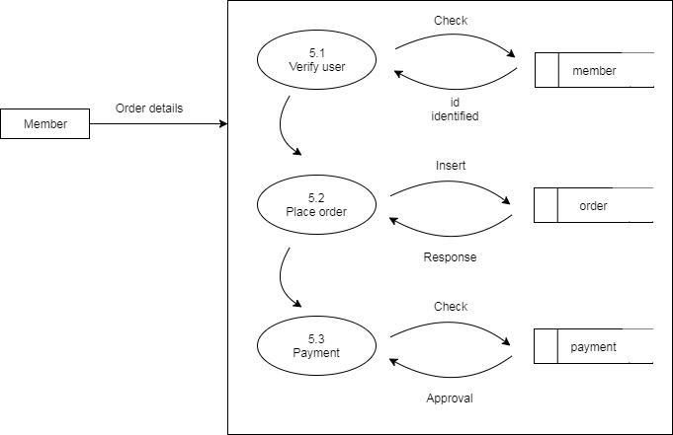**Data Flow Diagram (DFD) – Level 1 – 5.0 Place Order**

**Data Dictionary**

|  |  |
| --- | --- |
| **Entity Title** | Member |
| **Entity Type** | Strong |
| **Description** | A customer who register as a member of Peter’s Pizzeria with valid member account. |
| **In-flow** | Order confirmation (from Peter’s Pizzeria system) |
| **Out-flow** | Data key in by member such as member ID, Pizza type, size as well as quantity. |

|  |  |
| --- | --- |
| **Process** | 5.2 Place Order |
| **Description** | Process of member taking order from Peter’s Pizzeria online system via internet. |
| **Pre-condition** | The member must log in into the Peter’s Pizzeria online website before placing any order. |
| **In-flow** | * Member data and order details such as member ID, Pizza type, size as well as quantity (from member entity) * Insert record and response (from Order table) |
| **Out-flow** | * Start inserting new order row (into Order table) with member data and order details * Confirmation of order (to member entity) |

|  |  |
| --- | --- |
| **File/Data** | Order |
| **Description** | Table which store all the order details and record such as order ID, order date, order food name and so on from member and admin |
| **Pre-condition** | Nil |
| **Location** | Peter’s Pizzeria |
| **Size** | Infinite |
| **In-flow** | Start inserting new order record (from place order process) |
| **Out-flow** | Insert response and record (to place order process) |

### 9.0 Testing and Maintenance

**Testing**

|  |  |
| --- | --- |
| **Testing Type** | System Testing |
| **Definition** | Process to checking, testing, reviewing as well as verify the integrated system and ensure the system it meets all the specific requirements from client. |
| **Advantages of System Testing** | * Ensure the system can handle various of data efficiently with an appropriate manner and stratifying response speed. * Minimize the error when using in different platform of OS, server or browser. * Assure lower maintenance cost |
| **System Testing in Peter’s Pizzeria Online System** | Test Peter’s Pizzeria Online system in different platform of browser such as Chrome, Internet Explorer, Mozilla Firefox, Opera as well as Safari. Use some dummy data to test with the system in each distinct browser. For example, trying to purchase several pizzas by insert tying various of data. Eventually, performance and effectiveness or system used in different browser in evaluated. |

**Maintenance**

|  |  |  |
| --- | --- | --- |
| Adaptive Maintenance | **Type of Maintenance** | Perfective Maintenance |
| Process of changing and upgrading the software or system to ensure the software or system is useable and perform their function in changed or changing environment. | **Definition** | Process to modify and enhance the software product and system by maximizing performance all its components to make it trustworthy and perfect. |
| * Ensuring the software product is up-to-date meanwhile adapting and following the pace of technology and social. * Able to fulfil further requirements from diverse users as well as increase the capability and function of system. | **Benefits of Maintenance** | * Ensure the version of all the component of software and system are up-to-date and support the others latest program. * Provide faster responding speed, processing speed, higher security and increase in overall performance. |
| * Add support for mobile devices by developing special view for mobile devices so that user and visit and order pizza easily on online website of Peter’s Pizzeria by using their phone. * Add more available payment method for customer as there are plenty of third-party that provide online transaction function. For example, Alipay. | **Strategies Used for Maintenance** | * Update and renew the outdated hardware as well as software so that the system or software product will not be left behind the technology. * Compress the system file to minimize the waste of space. Indirectly, it increases the processing speed of system as the file size is small and it provides more extra free space to other upgrade and installation. |

### 

## Kua Chun Kit (TP042181)

### 8.0 Further Design

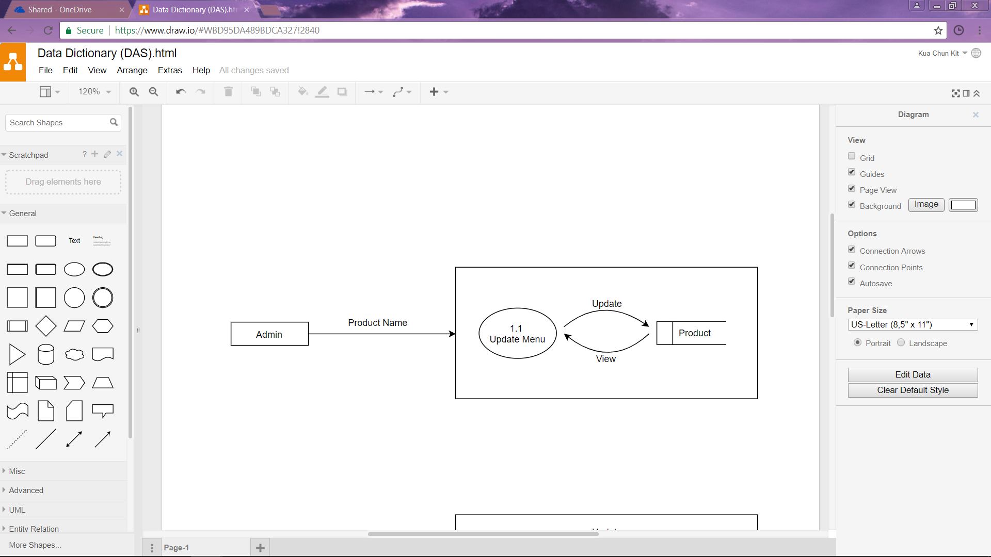**Data Flow Diagram (DFD) – Level 1 – 1.0 Update Menu**

**Data Dictionary**

|  |  |
| --- | --- |
| **Entity Title** | Admin |
| **Entity Type** | Strong |
| **Description** | Admin is administering of Peter’s Pizzeria. |
| **In-flow** | Data key-in by admin such as the name of product to update the status of products. |
| **Out-flow** | View the latest menu. |

|  |  |
| --- | --- |
| **Process** | 1.1 Update Menu |
| **Description** | This process is used when admin wants to update the menu from the information system. |
| **Pre-condition** | Admin need to be updated the status of products to be able to view the menu. |
| **In-flow** | * Search the name of product (from Admin entity). * Update menu of product (from menu table). |
| **Out-flow** | * View menu to ensure the status of product (to Admin entity). * Conformation to the update menu (to Admin entity). |

|  |  |
| --- | --- |
| **File/Data** | Product |
| **Description** | This file contains the available menu. |
| **Pre-condition** | Nil |
| **Location** | Information System Database |
| **Size** | Max 2GB or 300 set of products. |
| **In-flow** | Update the status of product (from Update Menu process). |
| **Out-flow** | View the available products that in the menu. |

### 9.0 Testing and Maintenance

**Testing**

|  |  |
| --- | --- |
| **Testing Type** | Integration Testing |
| **Definition** | A software development process which program units are combined and tested as groups in multiple ways. It can expose problems with the [interface](http://searchcio-midmarket.techtarget.com/definition/interface)s among program components before trouble occurs in real-world program execution. (Rouse, 2017) |
| **Advantages of Integration Testing** | * Provides a systematic technique for assembling a software system while conducting tests to uncover errors associated with interfacing. * To verify it meets the standards set by client as well as reassuring the development team that assumptions which were made during unit testing are correct. * To verify whether the software modules work in unity   (Ques10, 2012) |
| **Integration Testing in Peter’s Pizzeria Online System** | Test Peter’s Pizzeria Online System after completed the unit testing with combined all units. Ensure that all the units can normal operation such as database can access well with the placing order as to assure that the function is run as usual by placing any orders from customers’ site. |

**Maintenance**

|  |  |  |
| --- | --- | --- |
| Adaptive Maintenance | **Type of Maintenance** | Preventive Maintenance |
| Process of changing and upgrading the software or system to ensure the software or system is useable and perform their function in changed or changing environment. | **Definition** | Regularly review, detection, modification and take precaution against the initial state of failures before they become actual or main failures. Contrasted with corrective maintenance. |
| * Ensuring the software product is up-to-date meanwhile adapting and following the pace of technology and social. * Able to fulfil further requirements from diverse users as well as increase the capability and function of system. | **Benefits of Maintenance** | * Reduced overtime costs and more economical use of maintenance workers due to working on a scheduled basis instead of a crash basis to repair breakdowns * Improved safety and quality conditions for everyone * Timely, routine repairs circumvent fewer large-scale repairs |
| * Improve the online capability of Peter’s Pizzeria Online System. Customers able to visit the website with a speed of more smoothly. * Create employee portal which mobile devices can support. Thus, staffs can easily share and discuss information within Peter’s Pizzeria and keep all the staffs on the same page. | **Strategies Used for Maintenance** | * Install new anti-virus, anti-hacking or firewall software. Meanwhile, malicious users should not able to access or damage the system. * Analysis the problem report for patterns. Meanwhile, staffs able to identify the problems with details and solve the problems or bugs of the system as soon as possible. |

## Jeffer Lee Zi Feng (TP041903)

### 8.0 Further Design

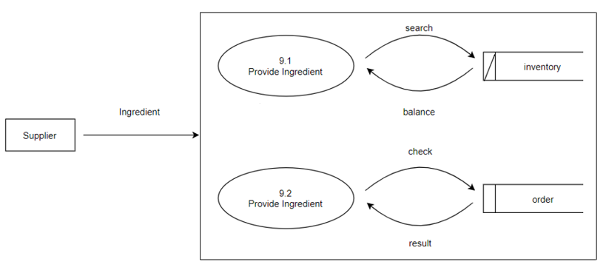**Data Flow Diagram (DFD) – Level 1 – 9.0 Supply Ingredients**

**Data Dictionary**

|  |  |
| --- | --- |
| **Entity Title** | Supplier |
| **Entity Type** | Strong |
| **Description** | Supplier is the one who supply ingredient to Peter’s Pizzeria |
| **In-flow** | Ingredients will provide by supplier according to the amount given by admin. |
| **Out-flow** | View the stock of ingredients that are capable to complete the orders. |

|  |  |
| --- | --- |
| **Process** | 9.1 Provide Ingredient |
| **Description** | This process is used when admin wants to restock the quantity of ingredients from the information system. |
| **Pre-condition** | Admin need to be updated to the stock of ingredients in order to view the availability of ingredients that can make the pizzas and accept more orders. |
| **In-flow** | Search the stock of ingredients. |
| **Out-flow** | View the balance of ingredients to ensure the stock of ingredients. |

|  |  |
| --- | --- |
| **File/Data** | Ingredients |
| **Description** | This file contains the stock of ingredients. |
| **Pre-condition** | Nil |
| **Location** | Information System Database |
| **Size** | Max 2GB or 300 set of products. |
| **In-flow** | Restock the quantity of ingredients ordered by admin (from Provide Ingredient process). |
| **Out-flow** | View the quantity of ingredients that in the stock. |

### 9.0 Testing and Maintenance

**Testing**

|  |  |
| --- | --- |
| **Testing Type** | Unit Testing |
| **Definition** | Level of software testing that tested individual units or components of a software. The purpose of this testing is to test the validity of each unit of the software where they are performed as designed. |
| **Advantages of Unit Testing** | * When a test fails, only the latest edited part need to be debug hence, debugging will be easy. * Codes are more reliable as software units are tested individually. * Guarantee of lower maintenance cost |
| **Unit Testing in Peter’s Pizzeria Online System** | Test Peter’s Pizzeria Online system specifically by testing each of the units to ensure each of the units are performed as designed. For instance, test Peter’s Pizzeria Online System placing order as to assure that the function is run as usual by placing any orders from customers’ site. |

**Maintenance**

|  |  |  |
| --- | --- | --- |
| **Corrective Maintenance** | **Type of Maintenance** | **Preventive Maintenance** |
| When developers want to restore failed system to its operable state, corrective maintenance is used to detect, segregate and remedy the mistake that have been done. Contrasted with preventive maintenance. | **Definition** | Regularly review, detection, modification and take precaution against the initial state of failures before they become actual or main failures. Contrasted with corrective maintenance. |
| * Reduced the requirement of emergency maintenance. * Concern the maintenance replacement and repair by providing appropriate data and information. | **Benefits of Maintenance** | * Increased the uptime to improve the performance of assets. * Maintenance team can respond faster to new problems as less unplanned maintenance. |
| * Maintenance team need to correct the failure that have been done to ensure that the order system can restore to it proper configuration settings. * Regularly update the drivers of the system to ensure the system is up-to-date and can be enhanced. | **Strategies Used for Maintenance** | * Check out the order system of Peter’s Pizzeria regularly to ensure that the initial problems can be solve earlier. * Develop standard backup schedule for the order system including off-site and cloud-based strategies to ensure the data and information will be kept safely. |

## Gan Hao Zhan (TP042328)

### 8.0 Further Design

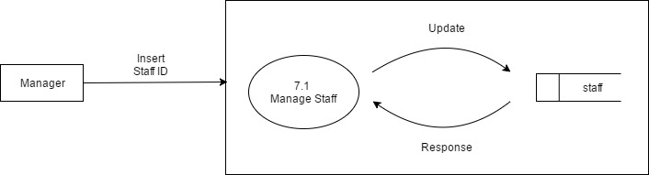**Data Flow Diagram (DFD) – Level 1 – 7.0 Manage Staff**

**Data Dictionary**

|  |  |
| --- | --- |
| **Entity Title** | Manager |
| **Entity Type** | Strong |
| **Description** | The manager of Peter’s Pizzeria. |
| **In-flow** | Staff ID inserted by manager to update the information of the staff. |
| **Out-flow** | View the result of staff’s information. |

|  |  |
| --- | --- |
| **Process** | 7.1 Manage staff |
| **Description** | This process is used to view or update the staff data exists in the database. |
| **Pre-condition** | Staff id needs to be inserted to the system. |
| **In-flow** | Insert the information of the staff. |
| **Out-flow** | Updated data of the staff will be shown. |

|  |  |
| --- | --- |
| **File/Data** | staff |
| **Description** | This file contains the data of staff. |
| **Pre-condition** | Nil |
| **Location** | Information System Database |
| **Size** | Max 2GB or 300 set of products. |
| **In-flow** | Update the information of the staff (from Manage staff process). |
| **Out-flow** | Staff’s information updated. |

### 9.0 Testing and Maintenance

**Testing**

|  |  |
| --- | --- |
| **Testing Type** | Unit Testing |
| **Definition** | A process that the smallest part in an application which are able to test, the method performed by testing individual unit of source code, sets of program module or procedure to validate the performance are as expected. |
| **Advantages of Unit Testing** | * We can find the bugs early as we test only certain part of the software, it is easier to trace the location if error occurs. * Programmers are able to refactor the code through unit testing, which can be updated later in the code library, it provides a more quality code in the process of development which codes has been restructured but remains the original code functions. Codes will be agile in order to adapt changes. |
| **Unit Testing in Peter’s Pizzeria Online System** | Unit testing carried out by testing each of the units in Peter’s Pizzeria Online system in order to ensure it validates all the requirements. For instance, we tested all the major and crucial units and function in Peter’s Pizzeria Online System such as manage staff and stock information by admin. |

**Maintenance**

|  |  |  |
| --- | --- | --- |
| **Perfective Maintenance** | **Type of Maintenance** | **Corrective Maintenance** |
| Process to modify and enhance the software product and system by maximizing performance all its components to make it trustworthy and perfect. | **Definition** | When developers want to restore failed system to its operable state, corrective maintenance is used to detect, segregate and remedy the mistake that have been done. Contrasted with preventive maintenance. |
| * Lifecycle of assets or system that is useful is extended hence the need for capital replacement will be largely decreases. * Enhances the performance of equipment which ensure them perform more efficiently and decreasing the power expenditures | **Benefits of Maintenance** | * The cost is low in short term as problems occurred should be solved as soon as possible. * Workload is lesser therefore it doesn’t require lot of staff. |
| * Using and keep updating to the latest hardware or software which can extend the lifecycle of the system. * Reduce the file size keep inside the database and keep reusing the structure and codes to make sure the system perform smooth and efficient. | **Strategies Used for Maintenance** | * Track down the bugs found or error reported by user and perform maintenance after analyse the problem. * Restoring the system that breakdown back to original version which perform as designed in the meanwhile determine the cause of the problem and fixed it in no time to prevent it. |

# References

Centers for Disease Control and Prevention (CDC), 2009. *Evaluation Briefs No. 18 January 2009 Data Collection Methods for Evaluation: Document Review.* [Online]   
Available at: https://www.cdc.gov/healthyyouth/evaluation/pdf/brief18.pdf  
[Accessed 15 08 2017].

dictionary, b., 2017. *business dictionary.* [Online]   
Available at: http://www.businessdictionary.com/definition/preventive-maintenance.html  
[Accessed 23 september 2017].

Dictionary, Y., 2017. *Your Dictionary.* [Online]   
Available at: http://www.yourdictionary.com/observation#lMg2VwploMbffGZK.99  
[Accessed 23 July 2017].

Iamglyka.Wordpress.com, 2013. *Schedule Feasibility.* [Online]   
Available at: https://iamglyka.wordpress.com/2013/02/06/schedule-feasibility/  
[Accessed 1 August 2017].

Ques10, 2012. *Ques10.* [Online]   
Available at: http://www.ques10.com/p/2200/discuss-the-advantage-and-disadvantage-of-integr-1/  
[Accessed 22 September 2017].

Rouse, M., 2017. *Search Software Quality.* [Online]   
Available at: http://searchsoftwarequality.techtarget.com/definition/integration-testing  
[Accessed 22 September 2017].

Simplicable.com, 2017. *Technical Feasibility.* [Online]   
Available at: http://simplicable.com/new/technical-feasibility)  
[Accessed 1 August 2017].

softwaretestingfundamentals, 2017. *softwaretestingfundamentals.* [Online]   
Available at: http://softwaretestingfundamentals.com/system-testing/  
[Accessed 26 September 2017].

testing, s., 2017. *software testing.* [Online]   
Available at: http://softwaretestingfundamentals.com/unit-testing/  
[Accessed 23 September 2017].

tipsforagreatwebpage, 2017. *tipsforagreatwebpage.* [Online]   
Available at: https://www.thoughtco.com/tips-for-a-great-web-page-3470063  
[Accessed 26 September 2017].

# Workload Matrix

